**Classroom Activity: Write a function that adds a click event listener to a button and executes a callback function when the button is clicked​**

**Html code:**

<!DOCTYPE html>

<html lang="en">

<head>

<meta charset="UTF-8">

<meta name="viewport" content="width=device-width, initial-scale=1.0">

<title>Button Click Event</title> </head>

<body>

<button id="myButton">Click Me</button>

<script src="script.js"></script> </body> </html>

**Script code:**

// Function to add a click event listener to a button

function addClickListener(buttonId, callback) {

const button = document.getElementById(buttonId);

if (button) {

button.addEventListener('click', callback);

} else {

console.error('Button with id ' + buttonId + ' not found.');

} }

// Callback function to be executed when the button is clicked

function handleButtonClick() {

alert('Button was clicked!'); }

// Add click event listener to the button with id 'myButton'

addClickListener('myButton', handleButtonClick);

**Output:**

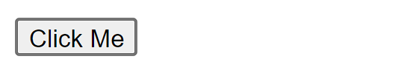

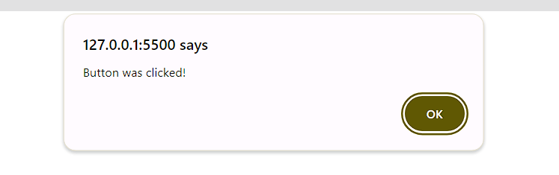

**Execution-Steps:**

* Create a JavaScript file with any name
* Write the code
* Run the code in the terminal using F5 or right click and go to inspect and you can get the output in the console as well.